**RoboApp**

**AKUnited**

Alex Vild, Luke Shays, Quintin Fettes, Seattle Ruzek, Zach Taylor, and Kurtis Davis

**Use Cases**

Project Overview:

RoboCat is a robotic cat that is controlled by an Android smartphone running the app called RoboApp. The purpose of RoboCat is for him to act like a regular cat. He has 12 Servos motors that will control his legs, 3 for each leg, plus Servos motors that control the movement (turning) of his head. He also has an Arduino board that will incorporate an ultrasonic sensor (which will be used for environment mapping). When the cat is in use, meaning that the phone is attached to RoboCat and RoboApp is running on the phone, he should be able to respond to various external stimuli. He responds to voice commands using natural language processing by the image of the cat on the Android phone screen changing emotions (smiling, frowning, etc). He should also be able to track a selected color if color tracking is running, and track faces using facial recognition.

Use Cases:

* RoboCat is talked to: He is being spoken to and is actively listening for a command.
* RoboCat is looking for a person: He is looking around and searching for a face using facial recognition.
* RoboCat is looking for a color: He is searching for a predetermined color and tracking its movement using color tracking.

Actors:

There are only two actors in this project, one is RoboCat and the other one is the user who is interacting with him.

Use Case Diagram:

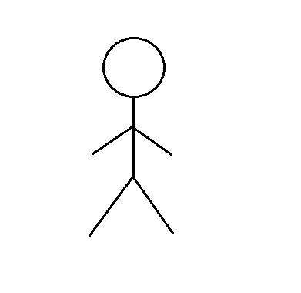

|  |  |
| --- | --- |
| **Pre Condition** | **Post Condition** |
| User gives RoboCat a command | RoboCat responds to command |
| None | RoboCat searches for a user’s face |
| None | RoboCat searches for a color |

**Technology Stack**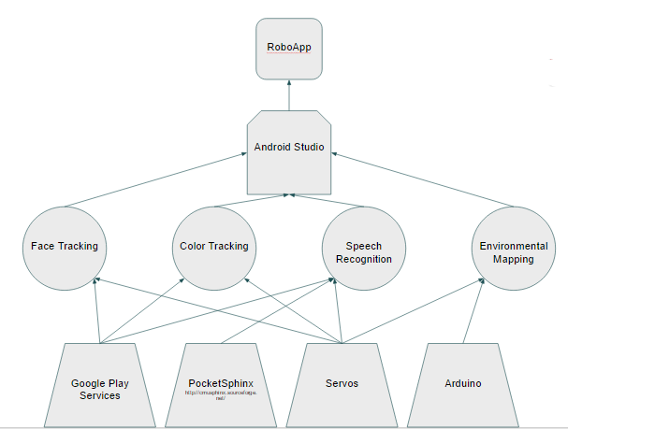

The entire project is controlled by RoboApp running on an Android phone. Android Studio is used to write the code for all of the functionalities of RoboApp.

Face tracking is a key part of RoboCat because it allows him to recognize and respond to the presence of people, similar to a real cat. Google play services are used to control Face Tracking, specifically the package com.google.android.gms.vision, and the Servos motors are used to turn his head to follow faces as he finds them.

Color tracking is done in a similar way, Google play services are used to implement color tracking, and then the servos motors are used to allow the cat to turn his head towards the color, and (once he is mobile) eventually RoboCat will follow the color that the user selected for tracking.

Speech recognition also uses Google play services, combined with PocketSphinx, and it is what enables RoboCat to change emotions when he is given commands. Servos motors will be used in the future when RoboCat is able to respond to user commands by moving.

Environmental mapping will be implemented using the Arduino board which will be connected to the ultrasonic sensor. The Servos motors will also be used so that RoboCat will be able to navigate his environment.

**Purpose-concept Map:**

Design:

The purpose of RoboCat is to behave like a regular cat would in different circumstances. We use the three main concepts described above to complete this goal: facial recognition, speech recognition, and environmental mapping.



**Key Concepts**: Interaction based on voice commands, movements, and the environment.

Pre-existing concepts:

* Facial recognition
* Responding to voice commands
* Reacting to environment through color tracking

**Analogic Concepts**

The camera and the microphone act as the eyes and the ears of RoboCat.

**Synthetic Concepts**

Since RoboCat is unable to move at this point, we cannot implement the concepts that require a moving cat, such as following a user, or navigating through the environment.

**System Architecture**

